

Table of Contents
Table of Contents 1
Application Design 2
Functional Overview 2
User Interface Overview 2
Management Interface Overview 2
Site Map 2
Security 2
Security Approach 2
New Relationship Manager Permissions 2
Web Page Design 3
Functional Description 3
Screen Print 3
Main Search 3
SubMain Search 3
Public Detail 4
Dealer Detail 4
Page Specifications 5
Buttons, Links & Content 5
Page Field Definitions 5
Exception Handling 5
Application Security Considerations 5
Content Security Considerations 5
Data Model Design 6
Proposed Database Structure Additions 6
Proposed Database Modifications 6
Data Conversion & Synchronization Approach 6
Testing Requirements 6
Test Conditions 6
Sample Test Data 6
Design Issues Log 6

Application Design

Functional Overview

User Interface Overview
- Search page will use drop down lists generated by available Groups and Types. The search should return different results based on “public” vs “dealer” user request.

Management Interface Overview

Site Map

Search by Group
Search by Sub Groups & Properties

Dealer

Public

Security

Security Approach
The standard security approach will be used.

New Relationship Manager Permissions
Identify and describe the new permissions that will be added to the product registration files (XML).
Permission Name | Permission Description

Web Page Design

Functional Description
The functional description is an explanation of the required functionality of a web page and its components. In this section, you should describe the processing logic, usability considerations, and security requirements.

Screen Print
Tip: Provide a link to the web page file rather than inserting the screen print image directly in the design document. This step reduces the design document size thereby making it more portable and manageable.

Main Search
Create a web page design section for every web page in the application. Replace the heading with the name of the web page.
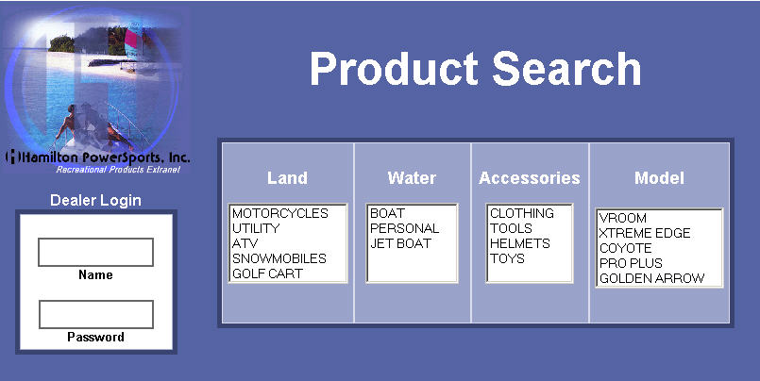

SubMain Search

Choice = Motorcycles
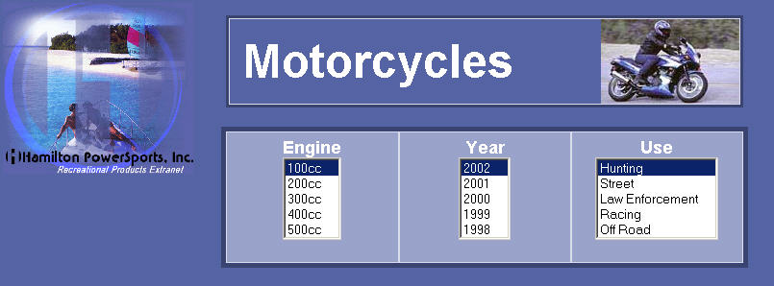

Public Detail
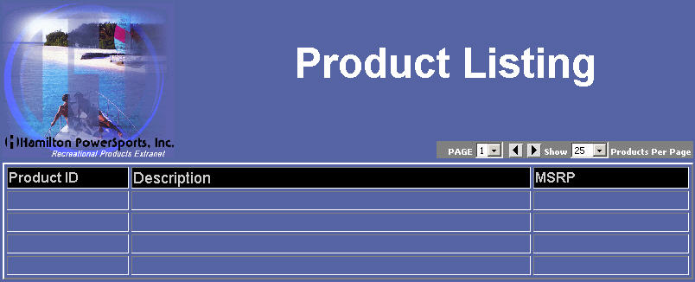

Dealer Detail
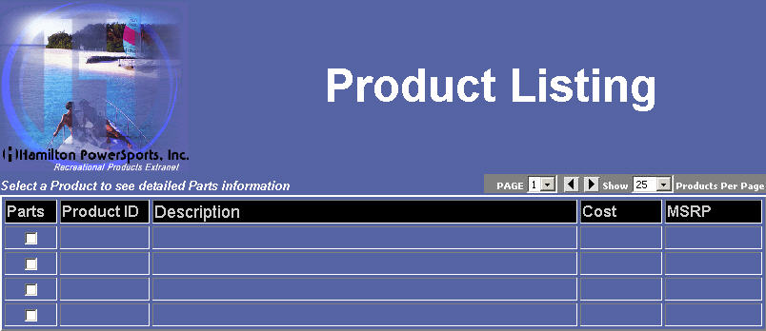

Page Specifications
Page Property | Specification Value
Page name
Pages linked from
Pages linked to
Associated permissions

Buttons, Links & Content
Create records for all buttons, links, and logic-driven content (e.g. images, text, banners…).
Object | Action | Response

Page Field Definitions
Create page field definition records for all form fields, hidden fields and formatted text.
Name | Type | Req.  /Opt. | Default | Validation/  Format | Data Source/ Destination | Description/Notes

Exception Handling
Identify potential errors and how each condition should be communicated to the user.
Condition | Error Message

Application Security Considerations
Identify page objects (e.g. buttons, links, menu options) and form fields that are subject to security requirements.
Controlled Objects/Fields | Scenario

Content Security Considerations
Identify content and data that are controlled. Describe the scenarios in which each are subject to security requirements.
Controlled Content | Scenario

Data Model Design

Proposed Database Structure Additions
Insert a table for each proposed database structure.
Table Name:
Field Name | Description

Proposed Database Modifications
Describe the proposed modifications to existing database structures.
Table Name | Field Name | Modification Description | Rationale

Data Conversion & Synchronization Approach
Describe the data conversion approach for each logical data set. If the data set will be maintained in more than one system or location, identify how the data will be synchronized.
Data Set | Approach

Testing Requirements

Test Conditions
Test Condition | Expected Result

Sample Test Data
Data Description | Sample Values

Design Issues Log

Date | Web Page | Issue | Resolution | Status | Date Resolved | Assigned To

